HANDOUT 6TH GRADE
UNIDAD TEMÁTICA | Unidad 1 “Food and health”
OBJETIVO (S) DE APRENDIZAJE | Reconocer vocabulario relacionado a deportes y estilos de vida sana.

I What’s your favorite sport? (Write and draw it) (escribe y dibuja tu deporte favorito)

II Match each Word with its correct picture
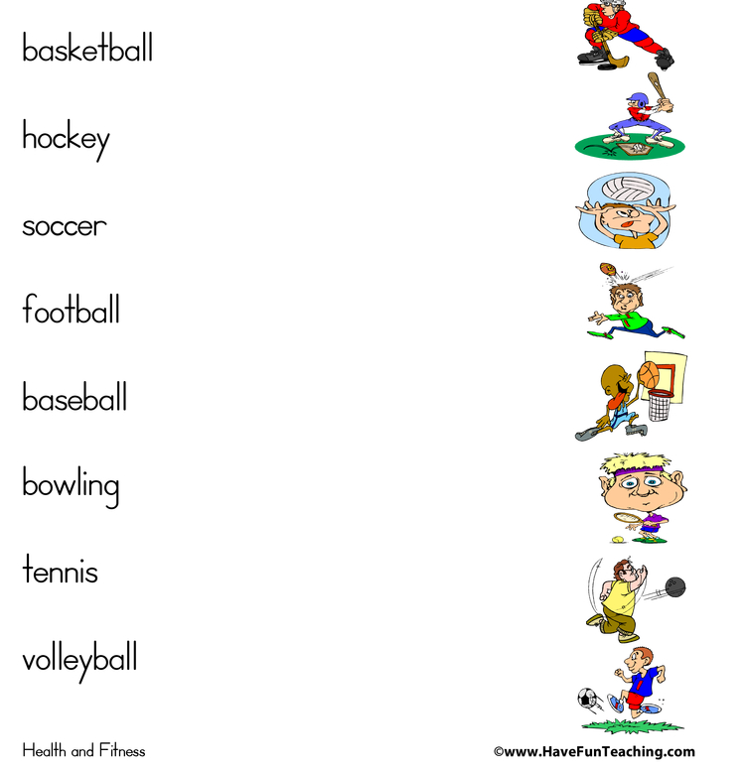

Team sports: sports that are practiced in groups or team.
Individual sports: sports that are practiced individually.

III Classify the sports in activity II into team sports and individual sport
TEAM SPORTS | INDIVIDUAL SPORTS

